To install kOps and kubectl

1. Create a server with any OS I am taking Amazonlinux2

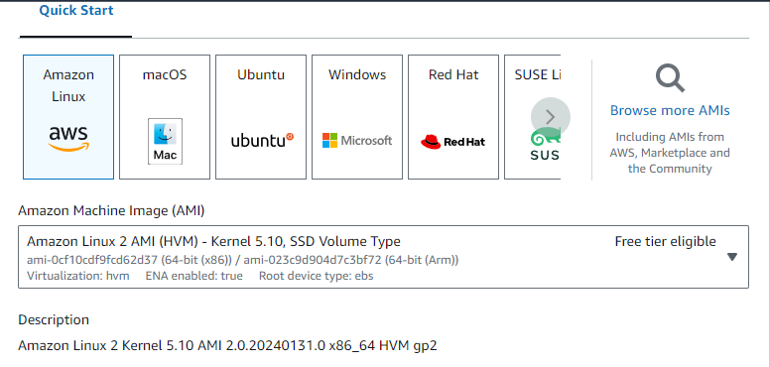

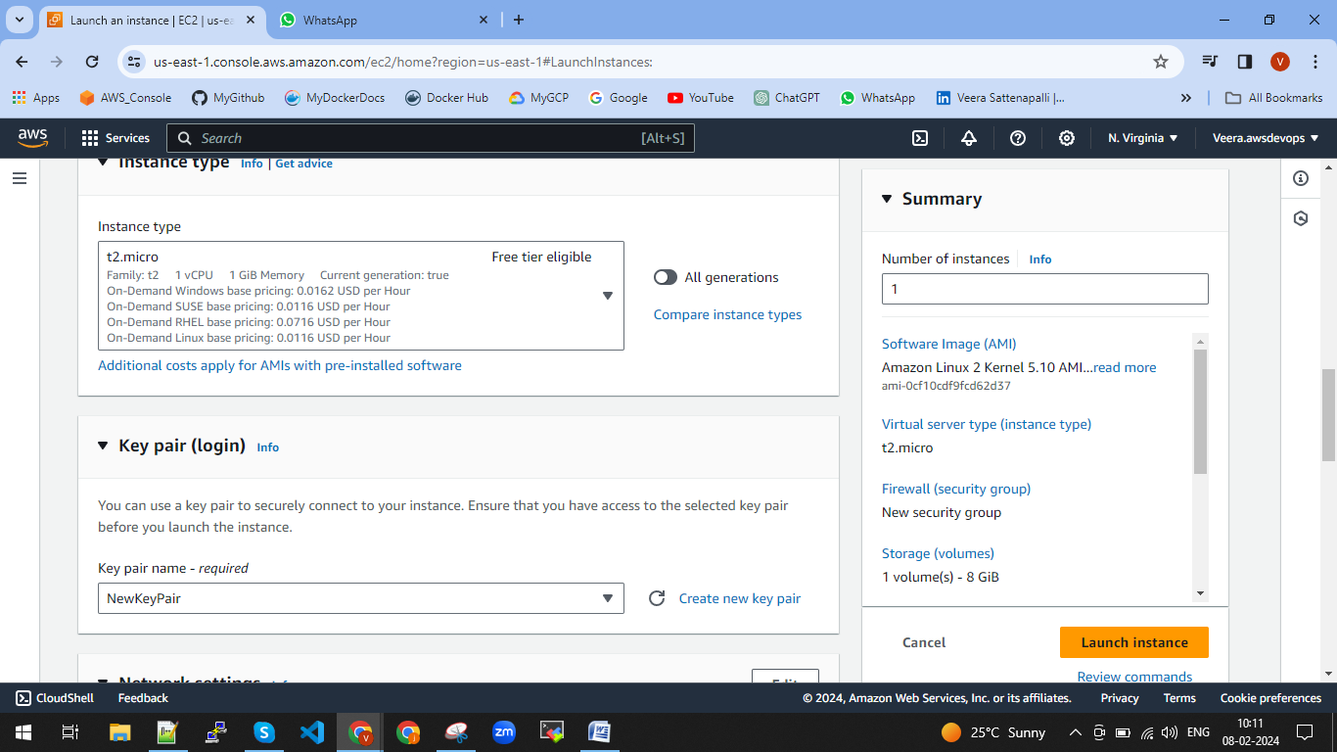

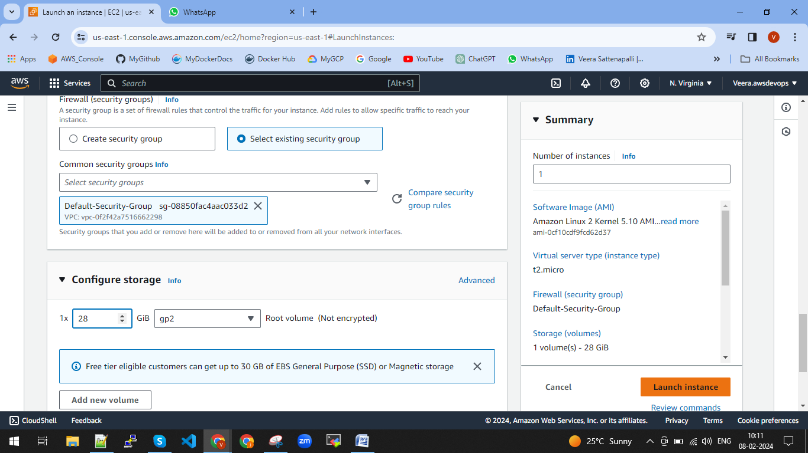

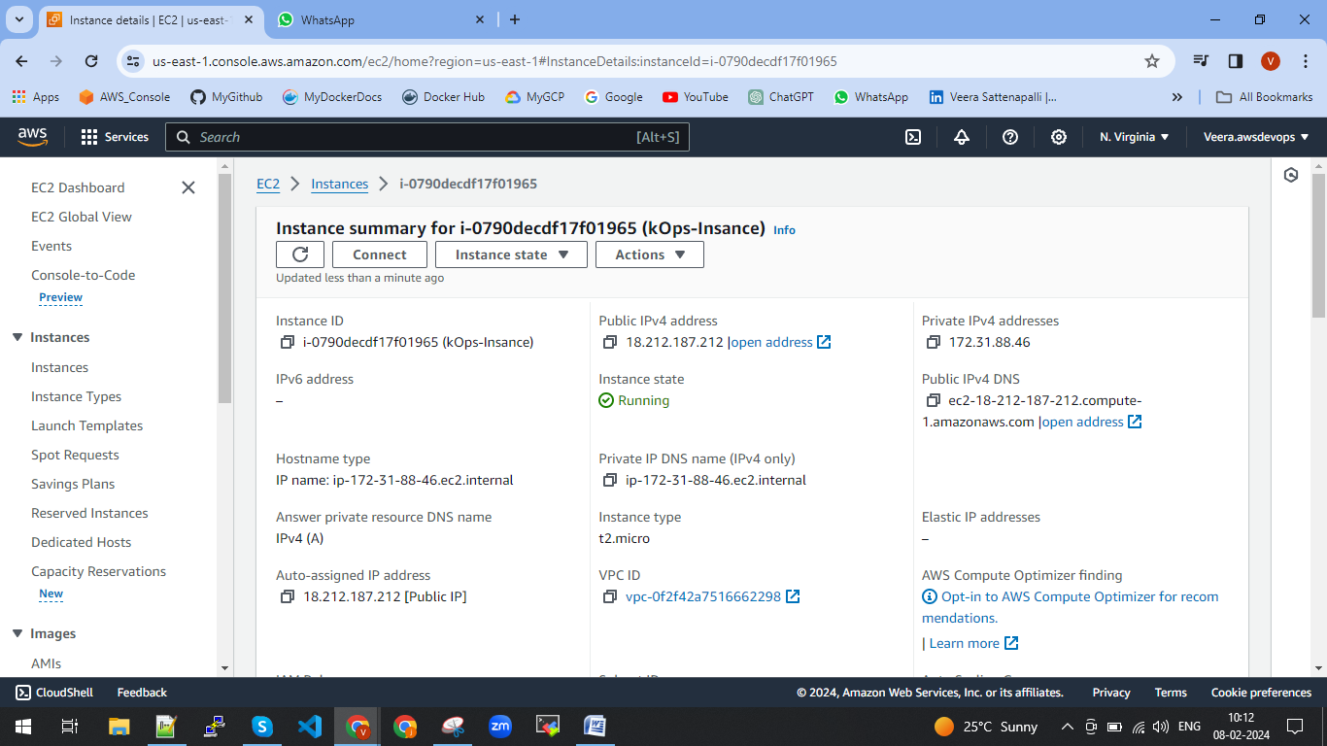

1. Install AWS CLI from the brouser

Using below link we can download the aws cli

https://docs.aws.amazon.com/cli/latest/userguide/getting-started-install.html

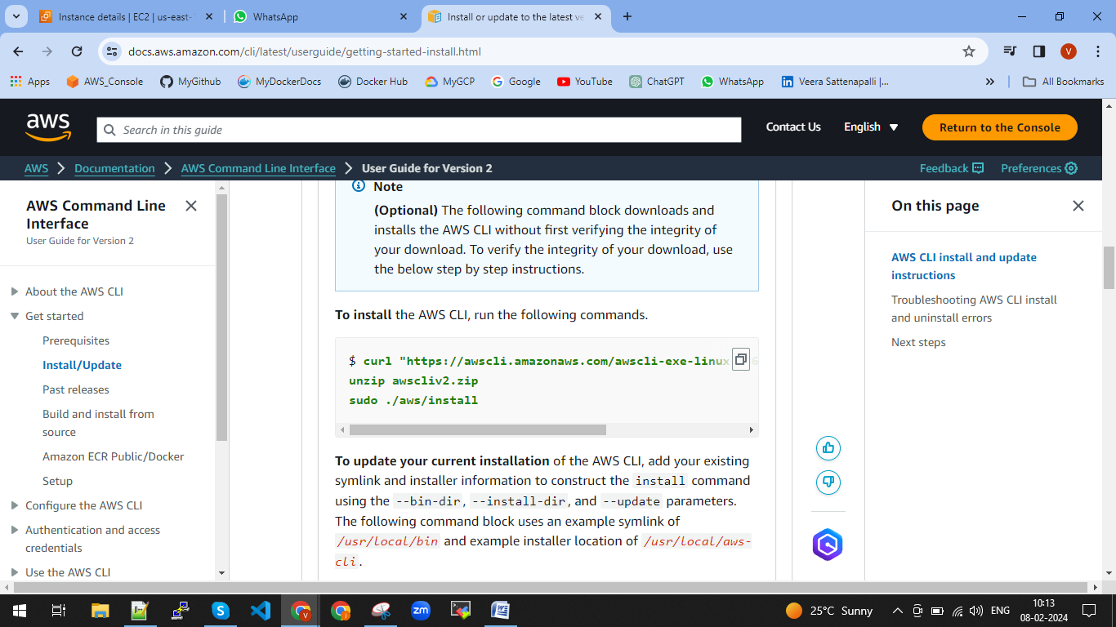

curl "https://awscli.amazonaws.com/awscli-exe-linux-x86_64.zip" -o "awscliv2.zip"

unzip awscliv2.zip

sudo ./aws/install

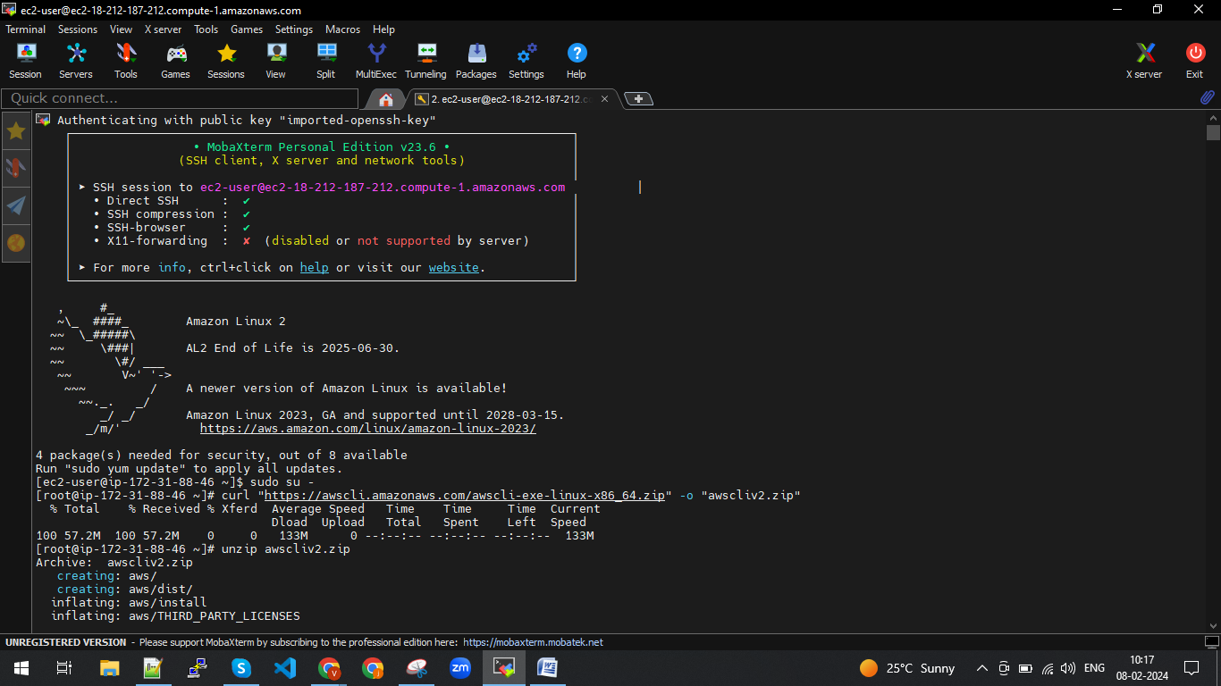

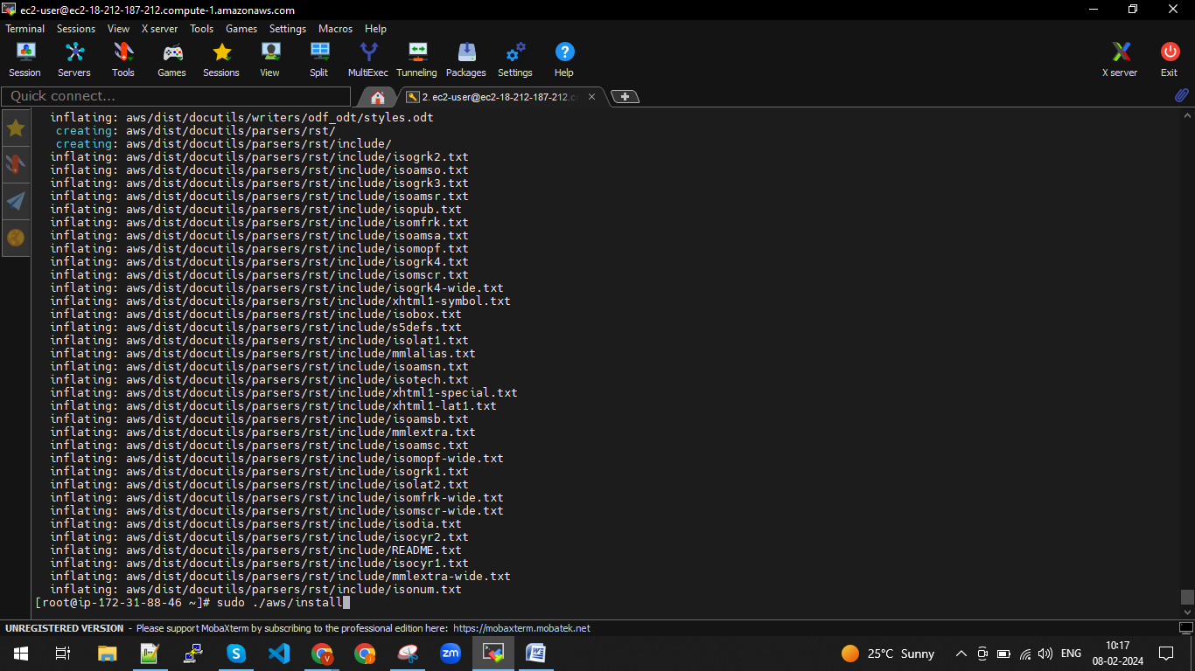

Press enter, after we will get path link as below

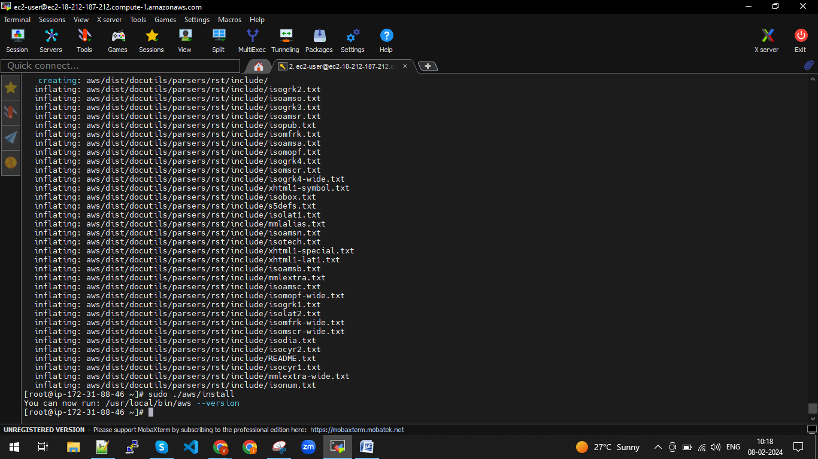

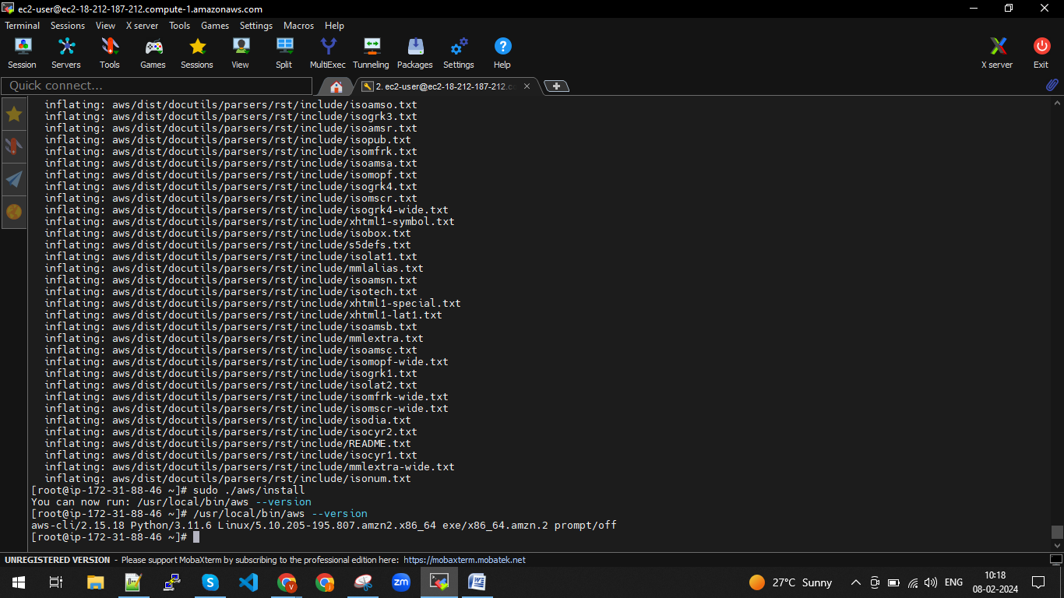

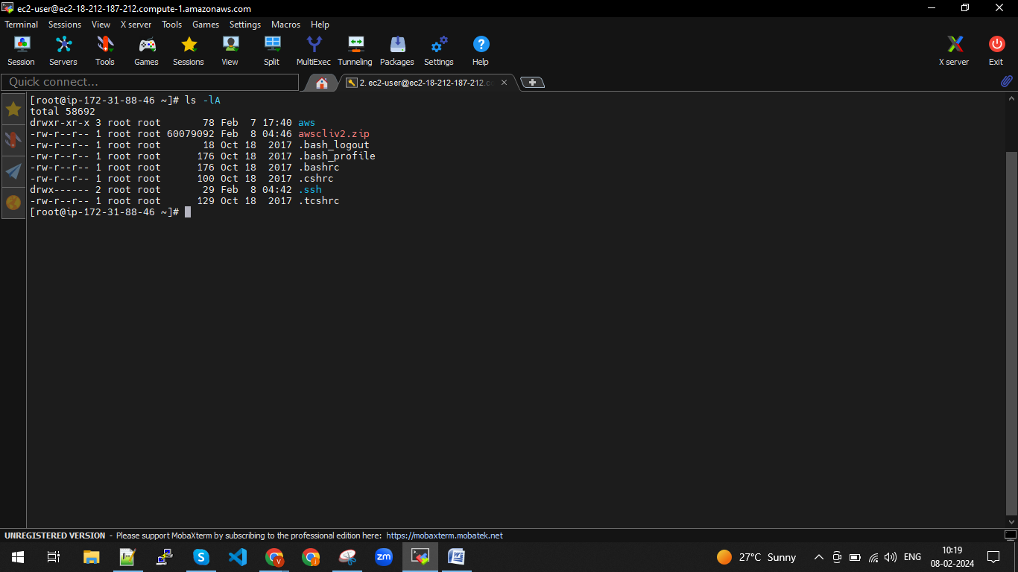

Open the .bashrc file and add

vim .bashrc

export PATH=$PATH/usr/local/bin/

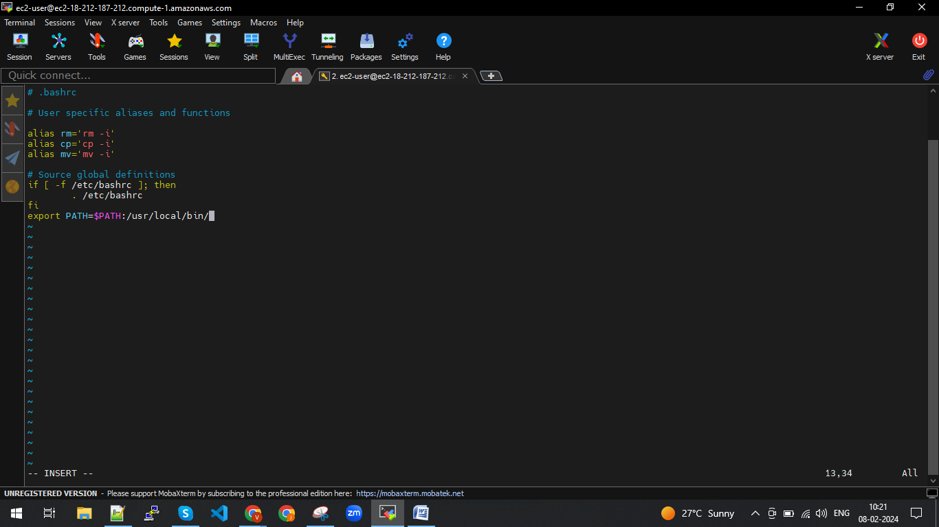

Save it.

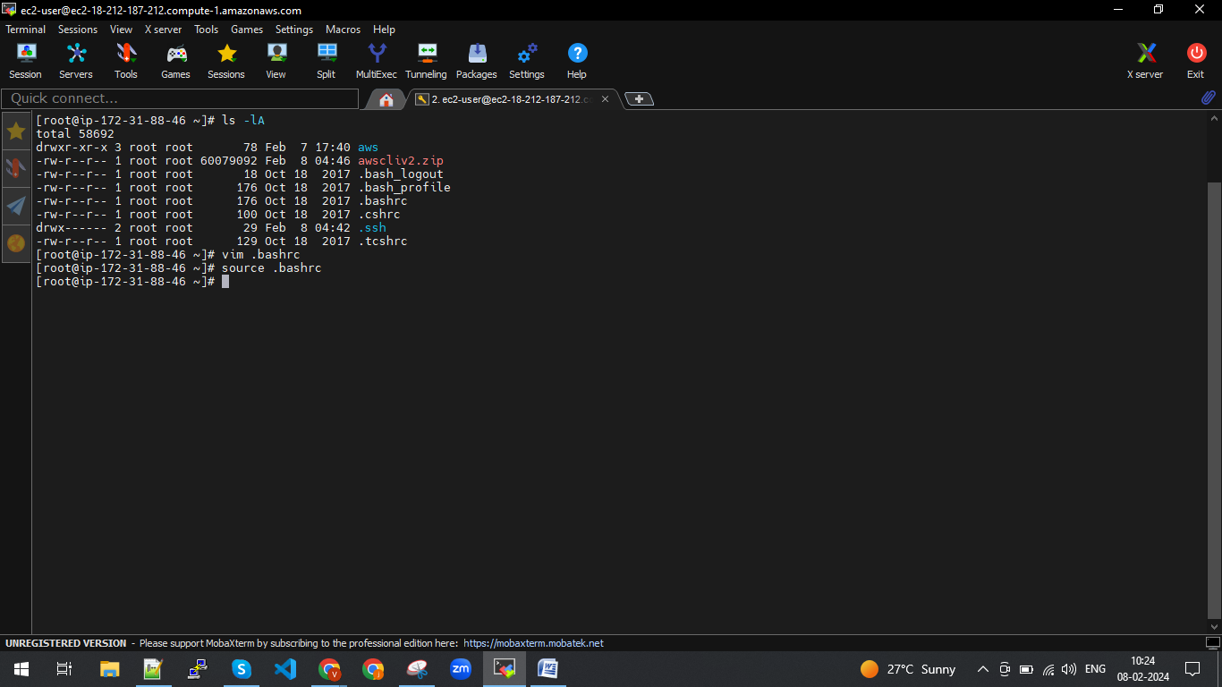

Do source .bashrc

1. Install kubectl using below link

<https://kubernetes.io/docs/tasks/tools/install-kubectl-linux/>

curl -LO "https://dl.k8s.io/release/**$(**curl -L -s https://dl.k8s.io/release/stable.txt**)**/bin/linux/amd64/kubectl"

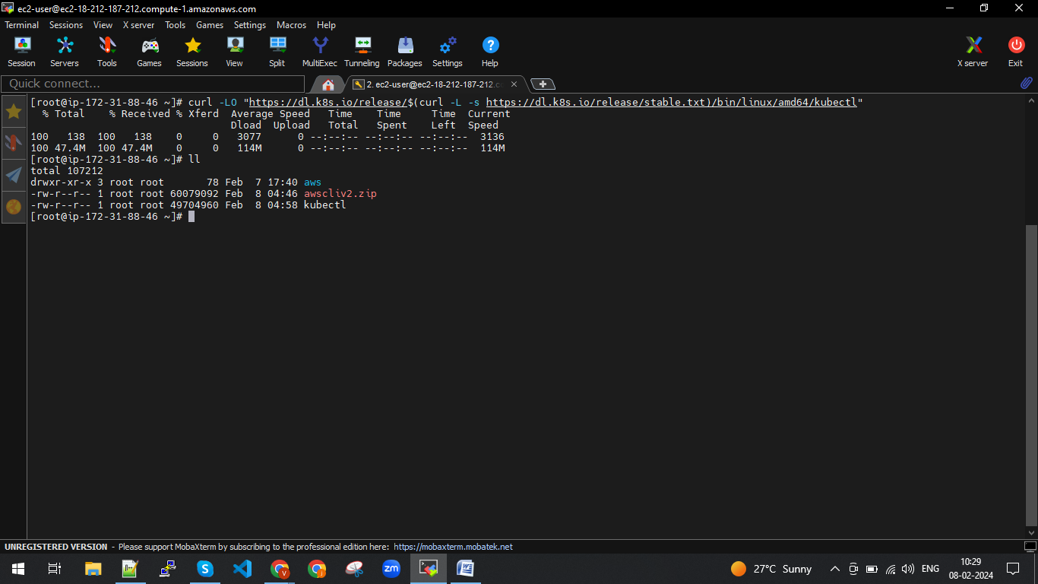

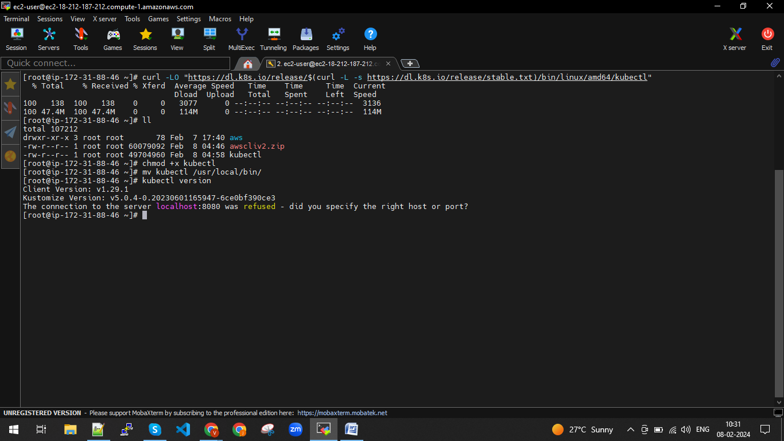

1. Install kOps using below link

<https://kops.sigs.k8s.io/getting_started/install/>

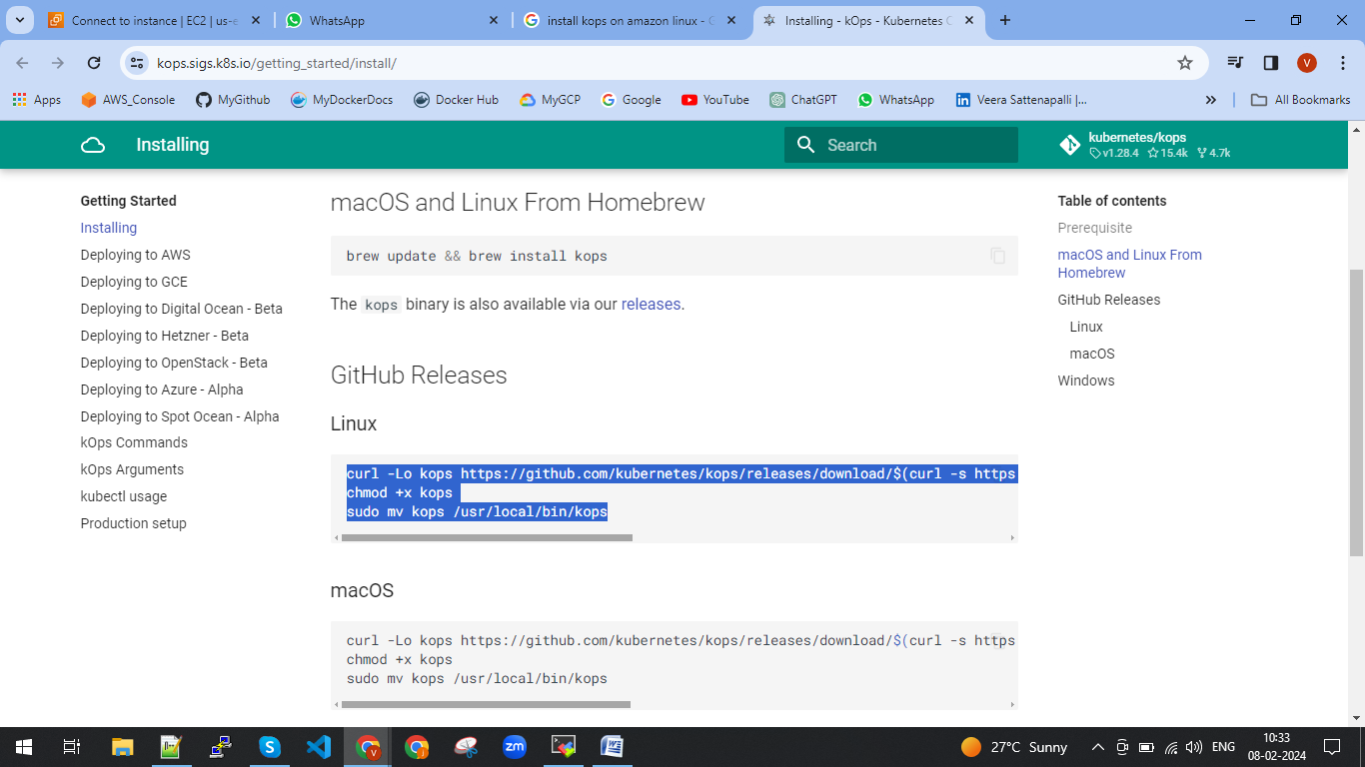

curl -Lo kops https://github.com/kubernetes/kops/releases/download/$(curl -s https://api.github.com/repos/kubernetes/kops/releases/latest | grep tag_name | cut -d '"' -f 4)/kops-linux-amd64

chmod +x kops

sudo mv kops /usr/local/bin/kops

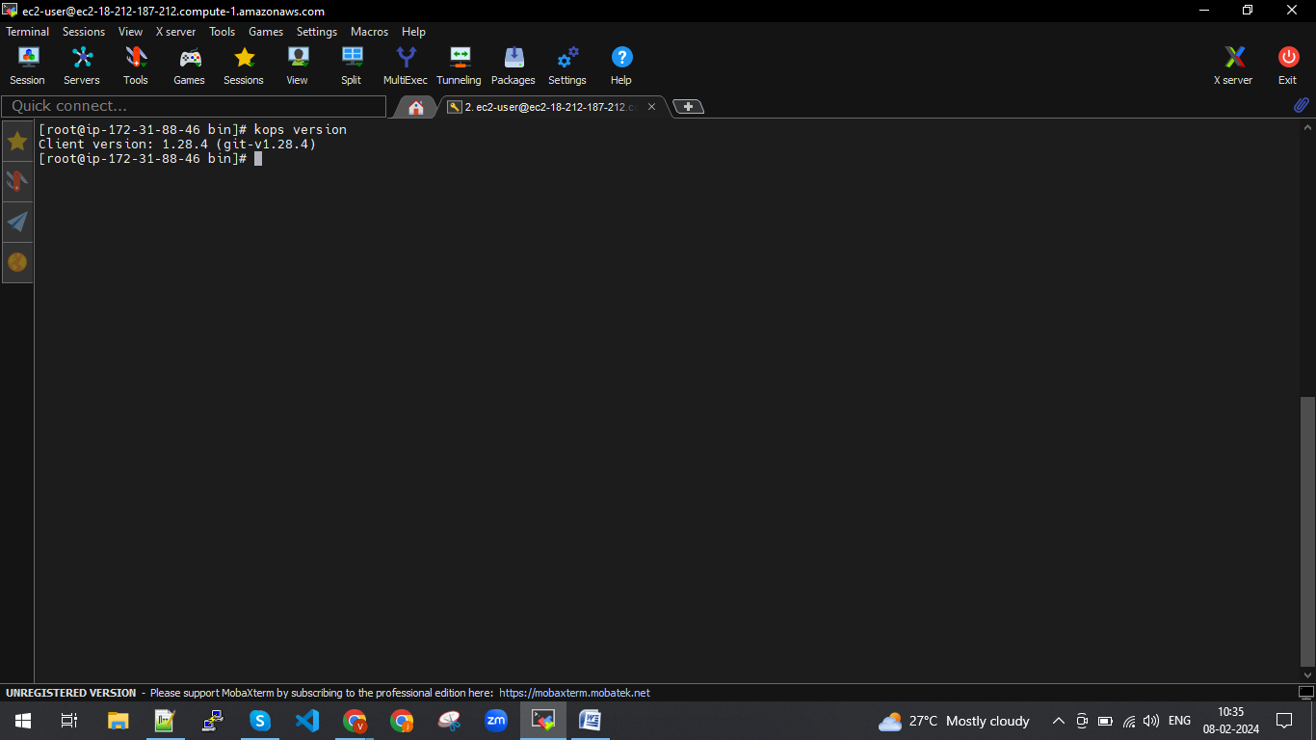

1. IAM user cerate and give administrative access

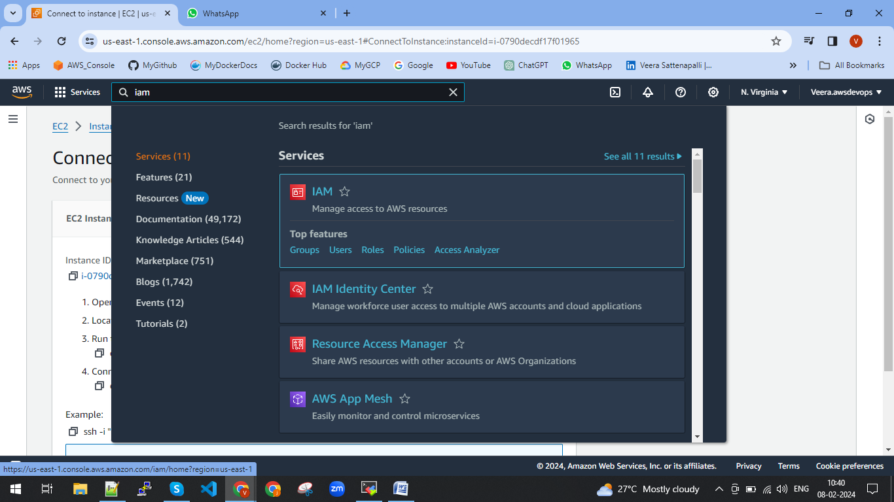

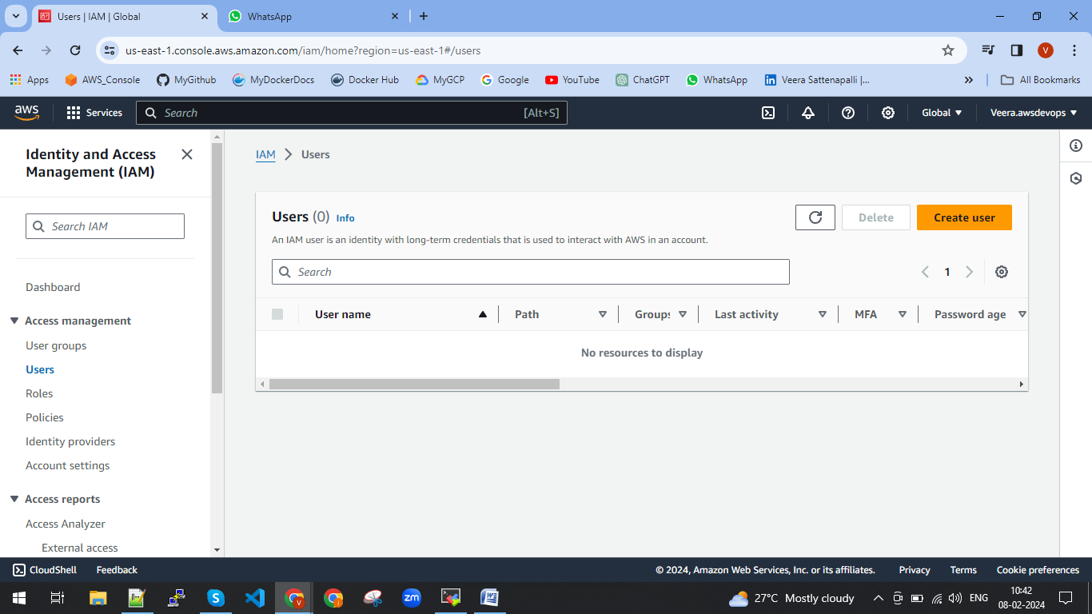

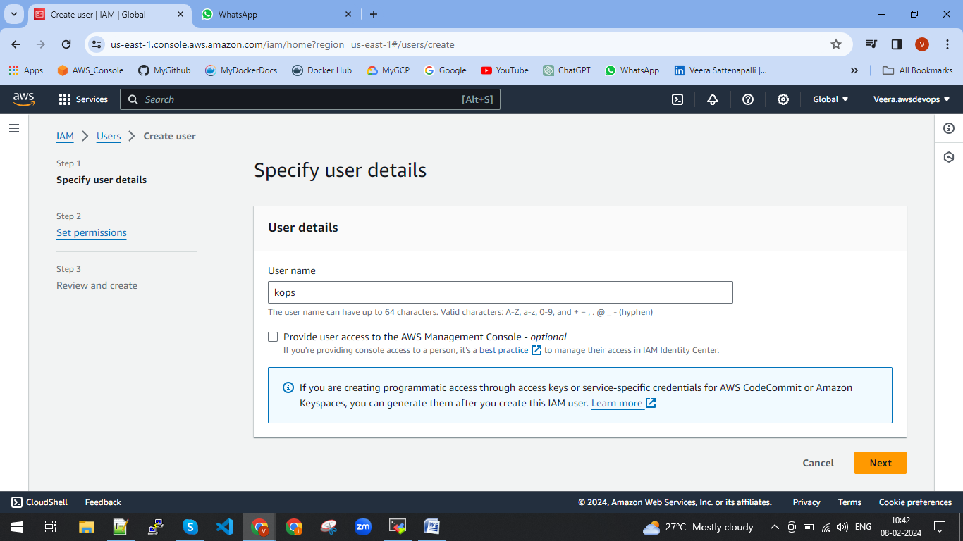

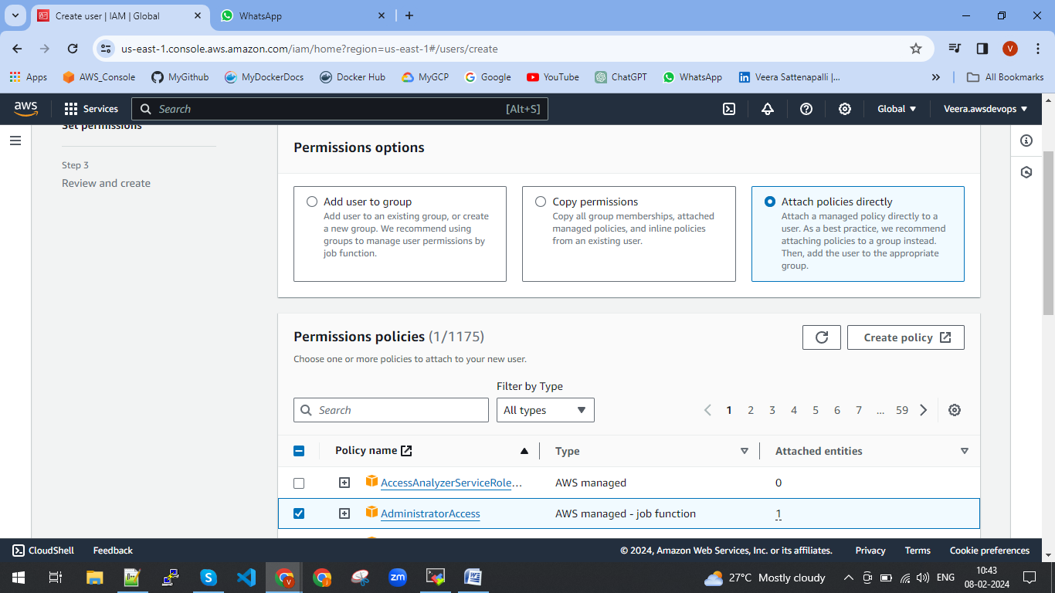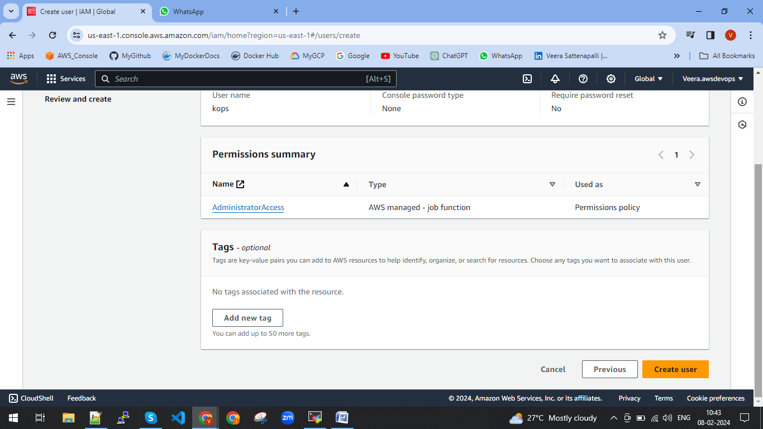

Create user.

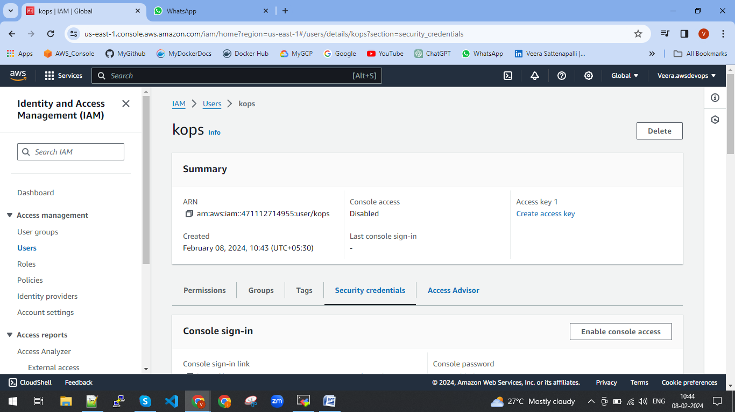

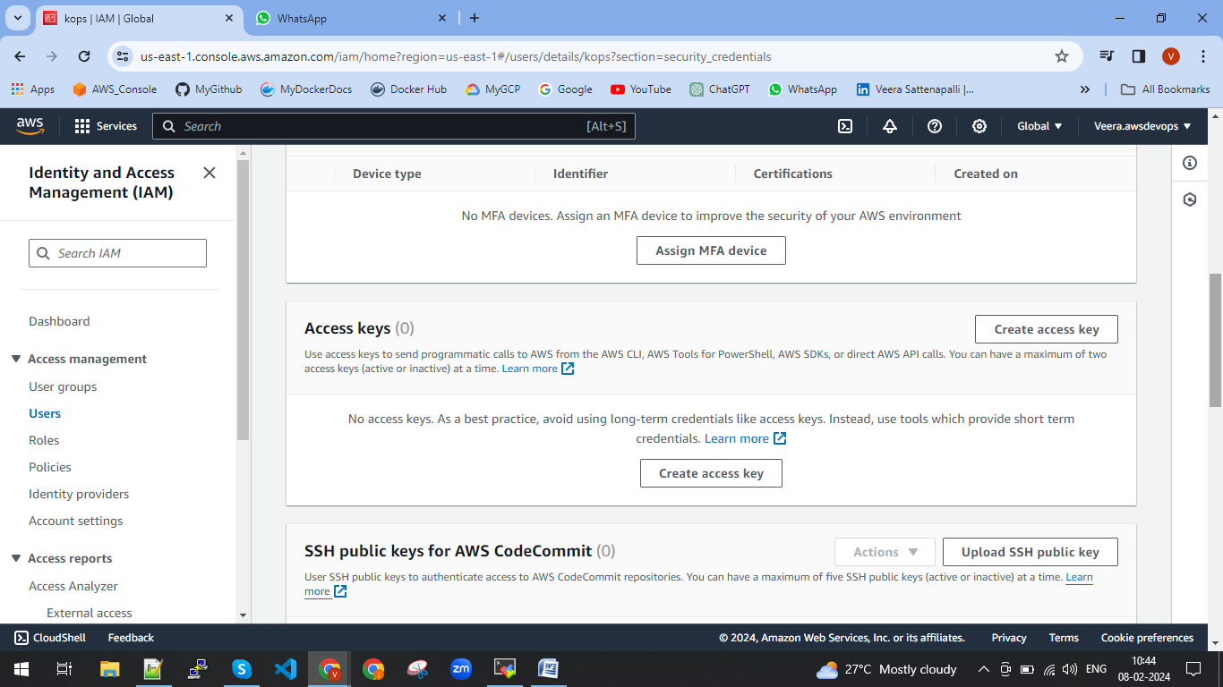

Create access key in the Security credentials

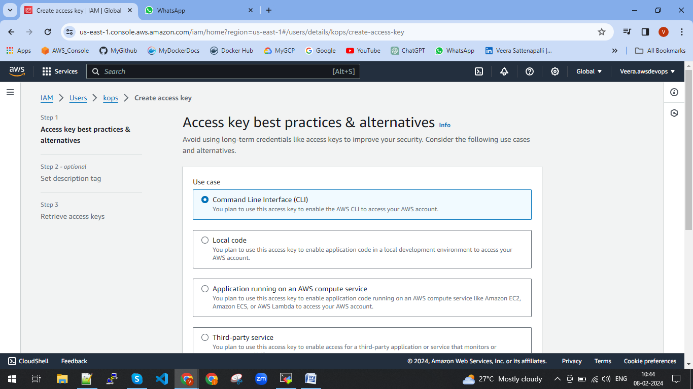

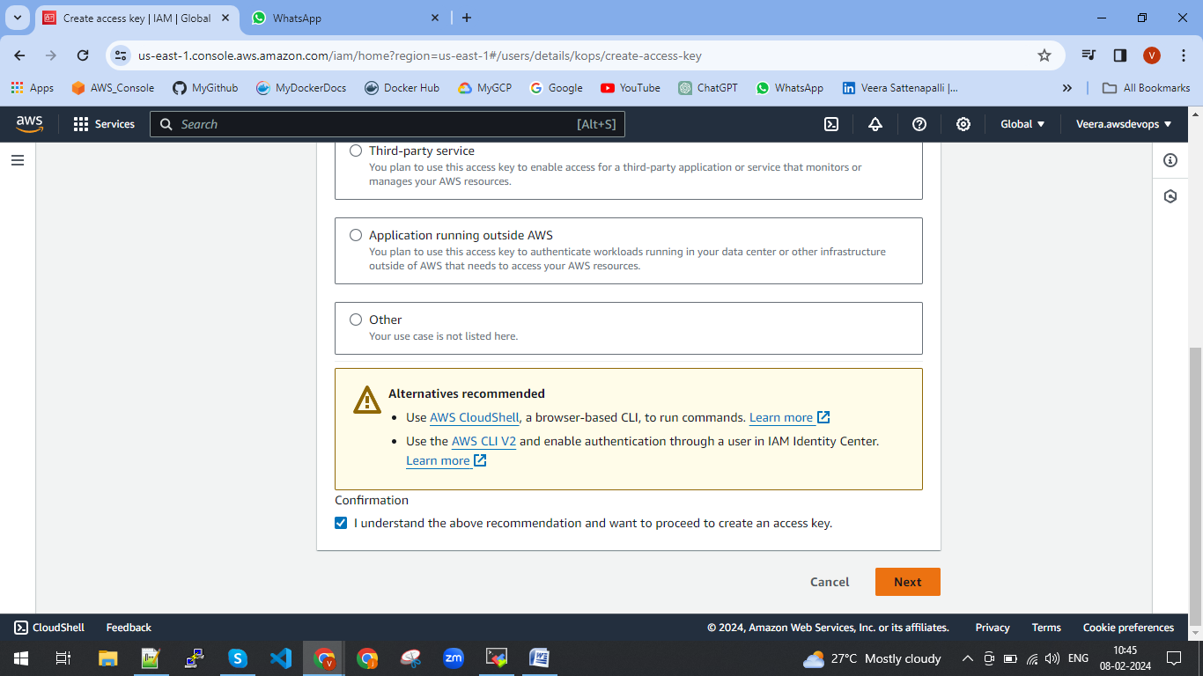

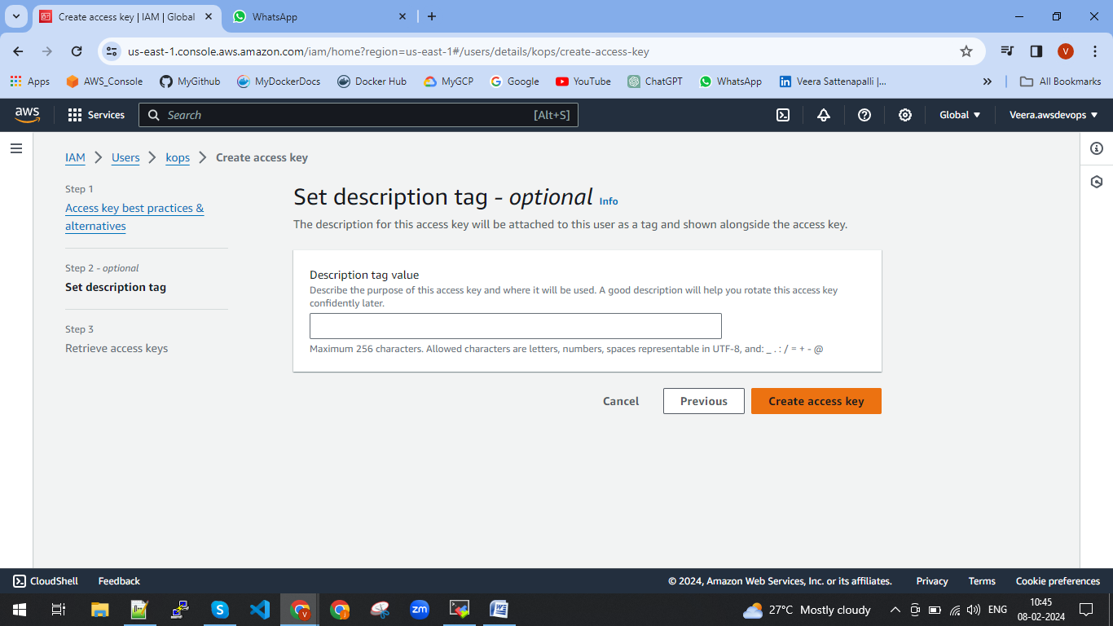

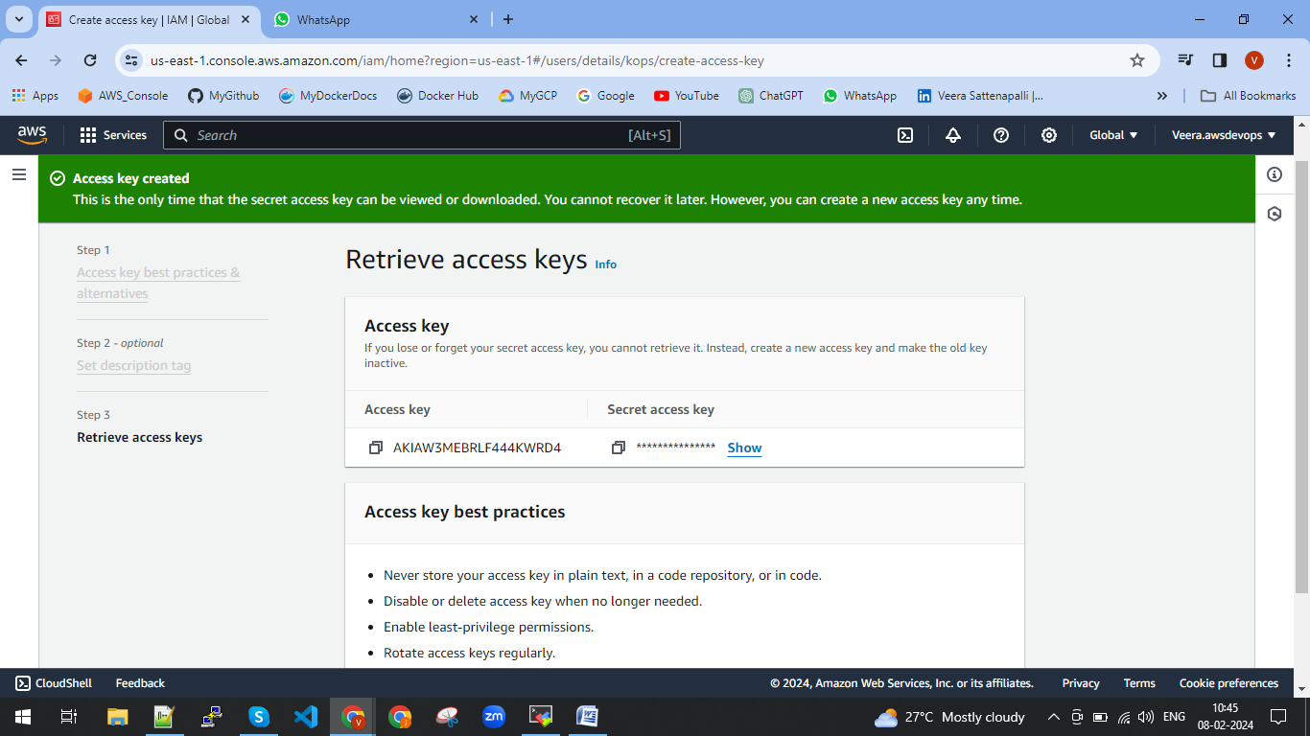

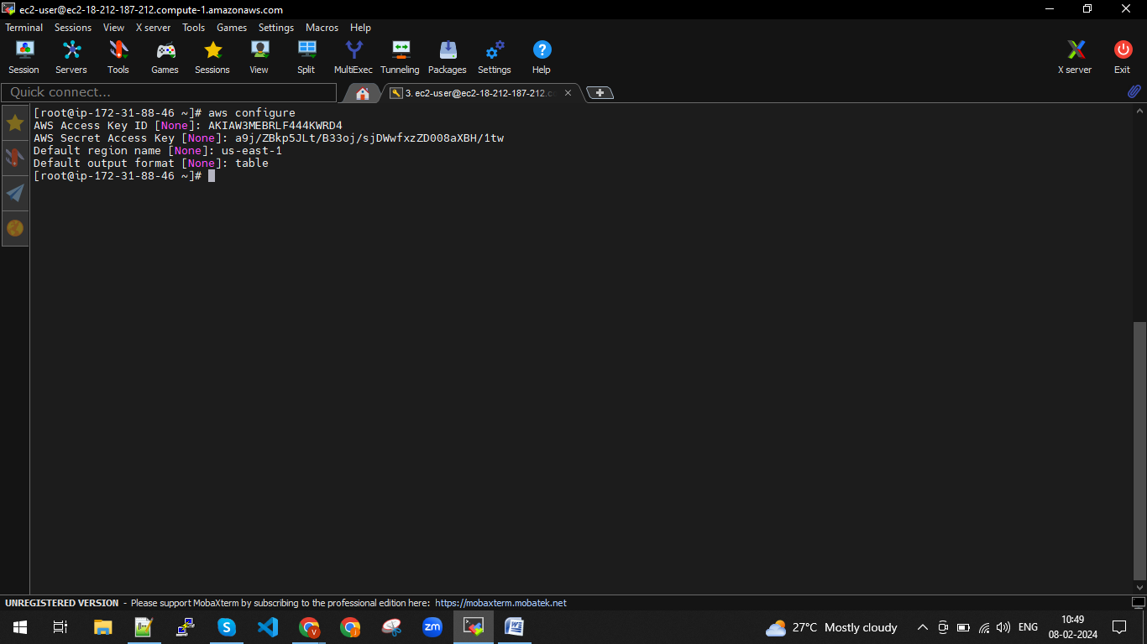

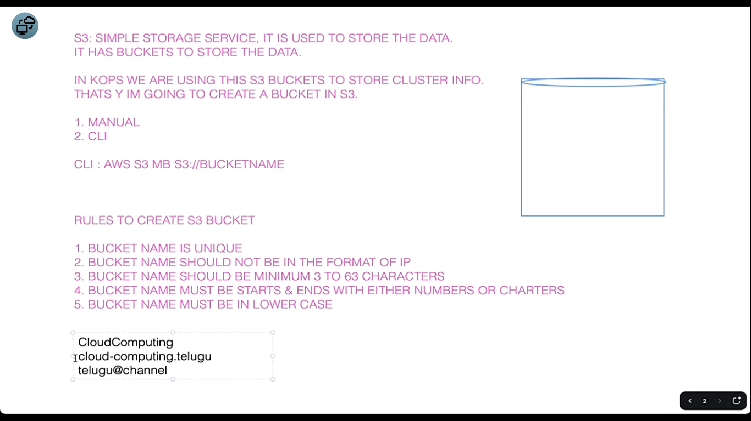

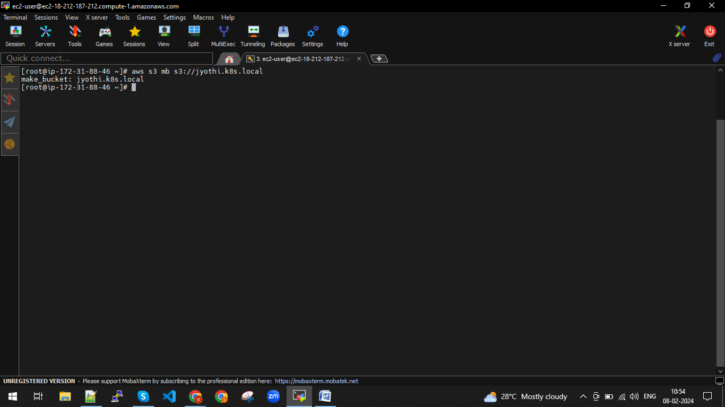

To link cluster to s3 bucket we need to export by using below command

export KOPS_STATE_STORE=s3://jyothi.k8s.local

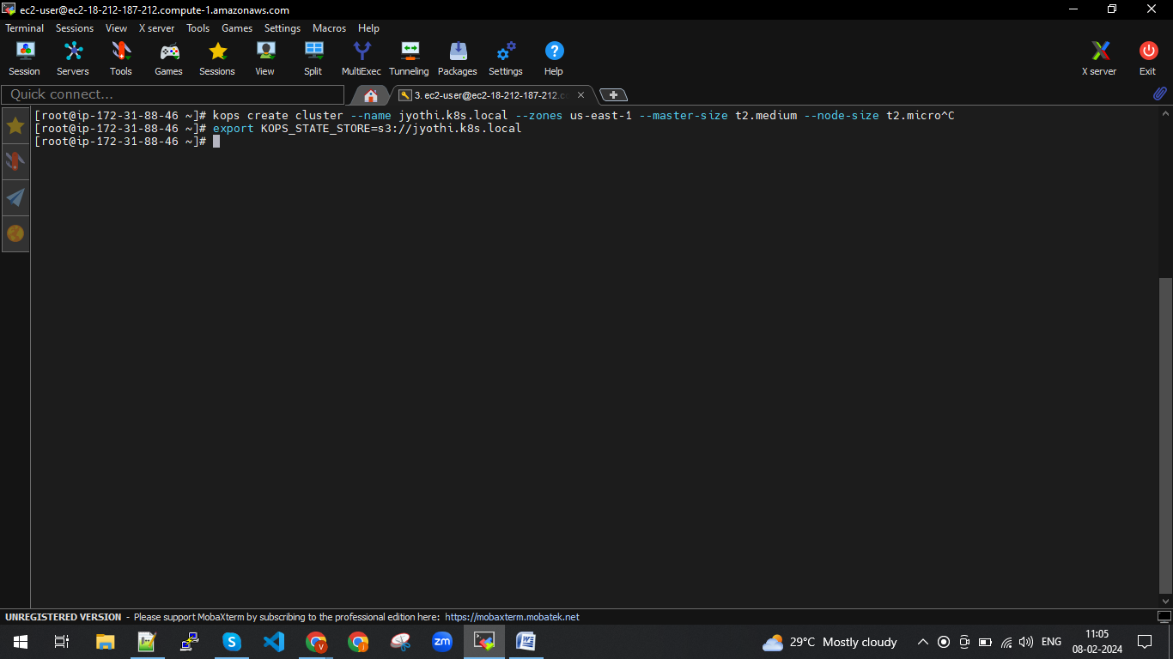

Kubernetes

kops

Master node

API server

To make a link between our server and cluster we need to generate a link.

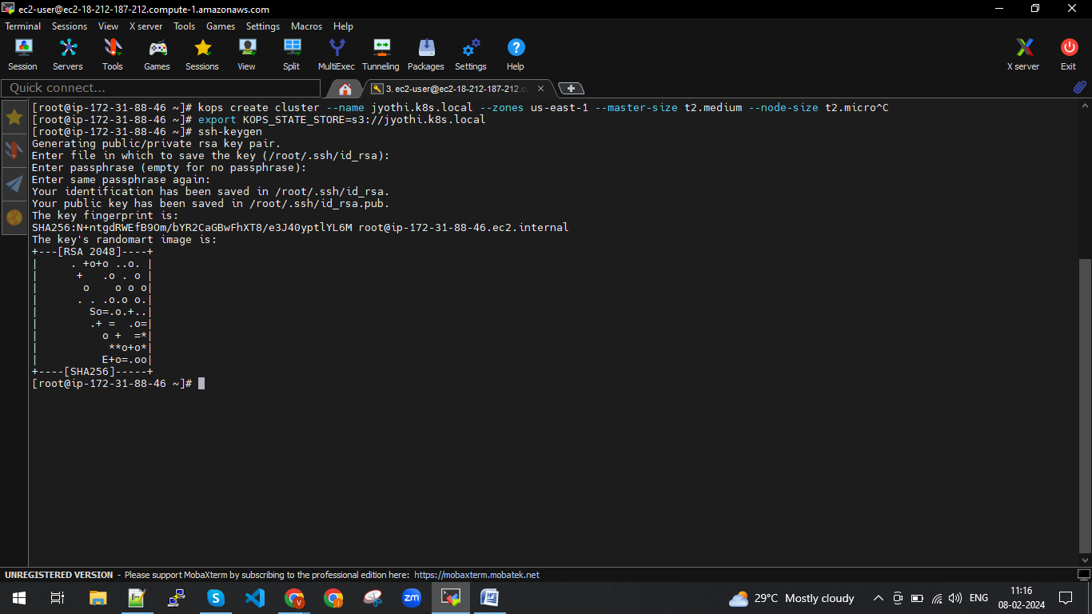

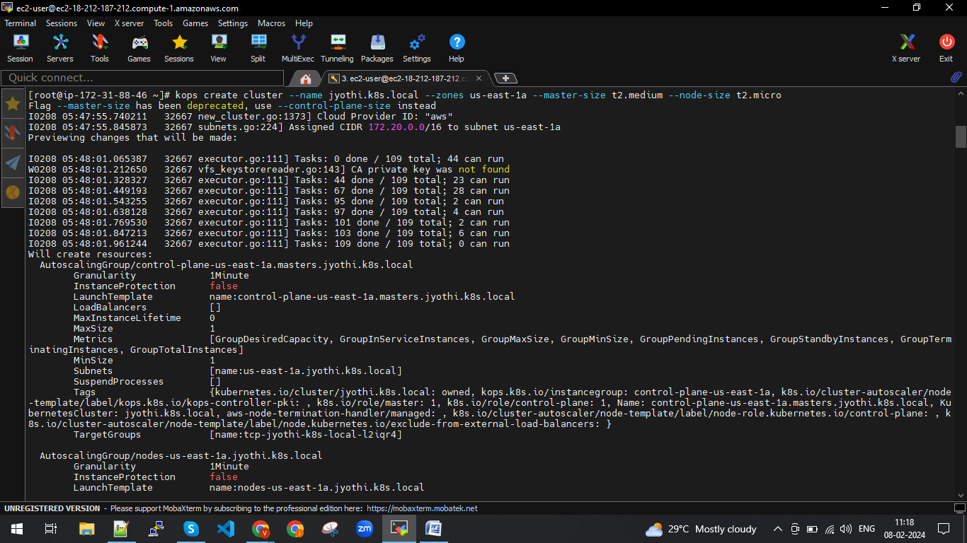

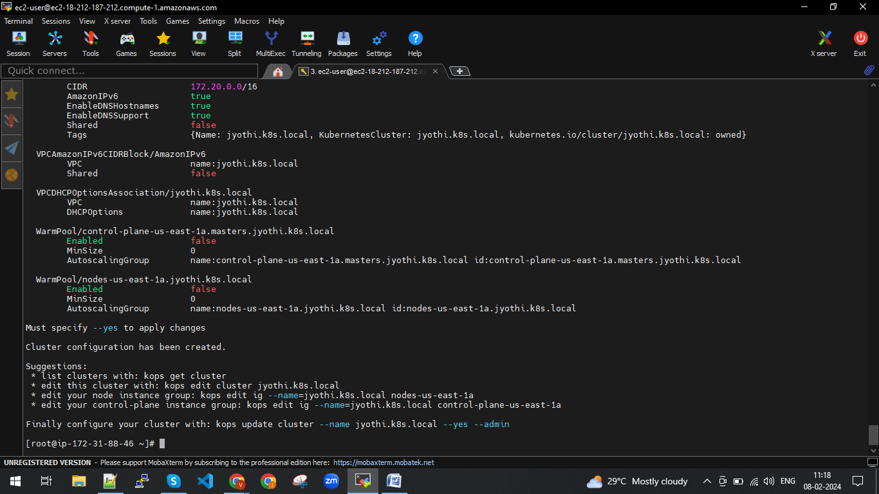

Suggestions:

* list clusters with: kops get cluster

* edit this cluster with: kops edit cluster jyothi.k8s.local

* edit your node instance group: kops edit ig --name=jyothi.k8s.local nodes-us-east-1a

* edit your control-plane instance group: kops edit ig --name=jyothi.k8s.local control-plane-us-east-1a

Finally configure your cluster with: kops update cluster --name jyothi.k8s.local --yes –admin

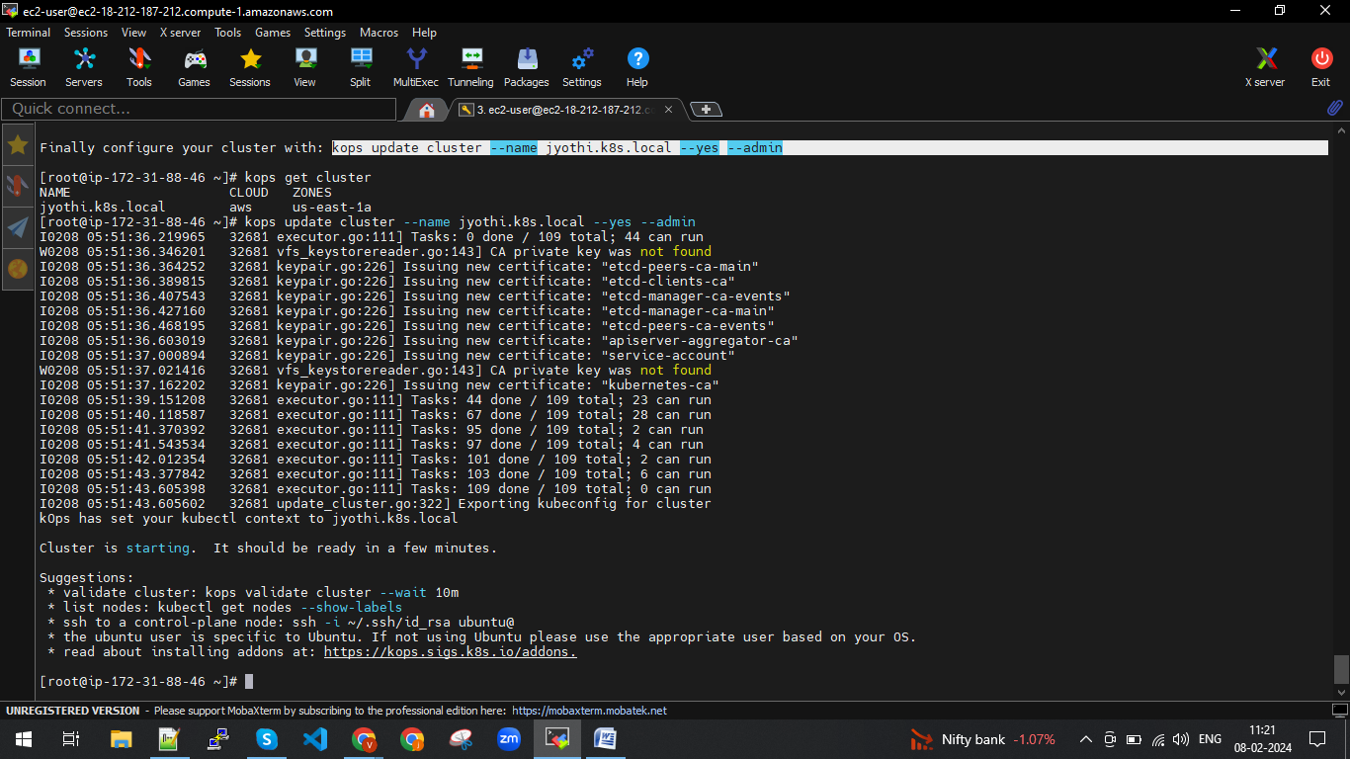

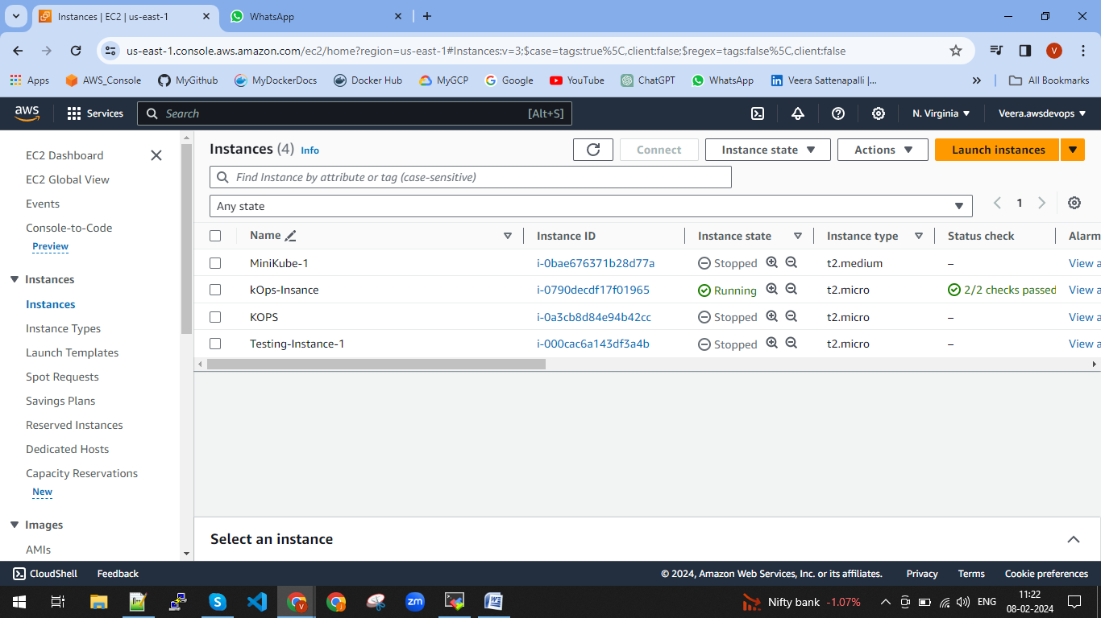

We do not have any instanceses master and worker nodes once above cluster is starting we will get below

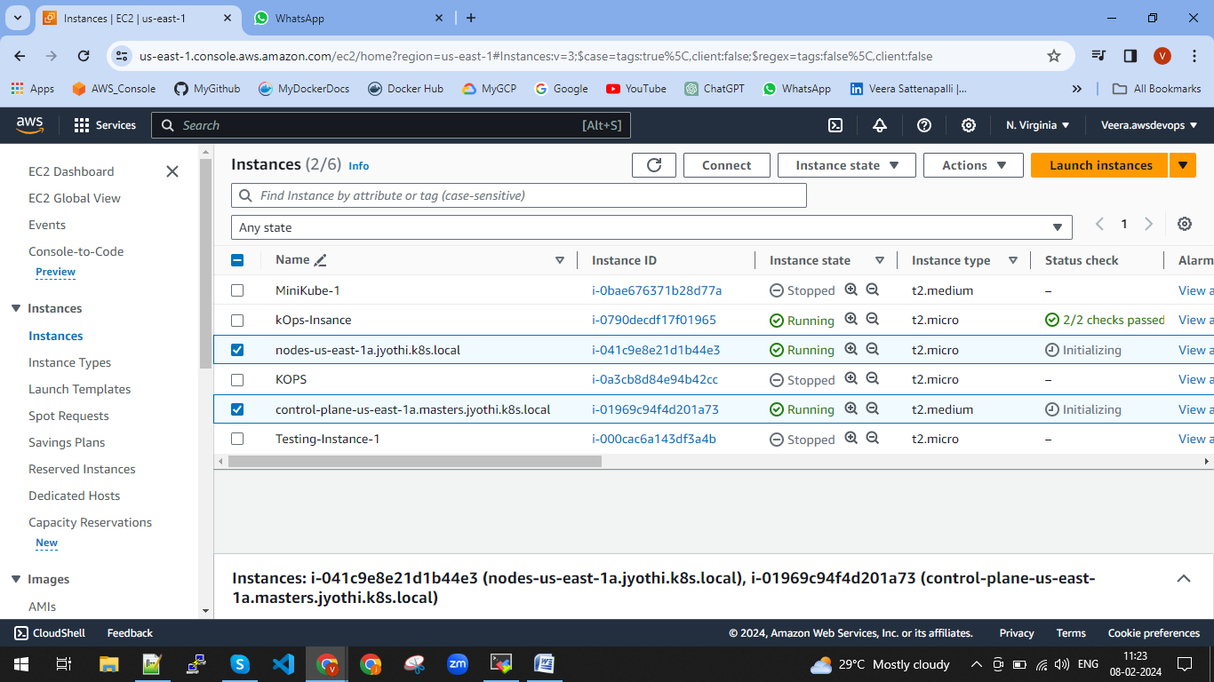

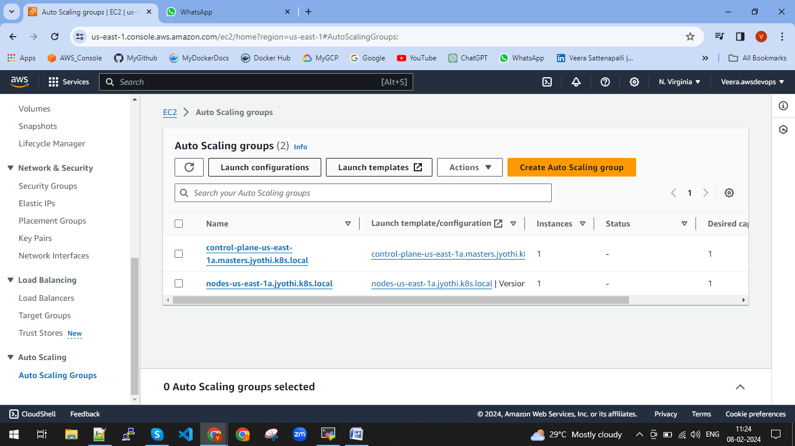

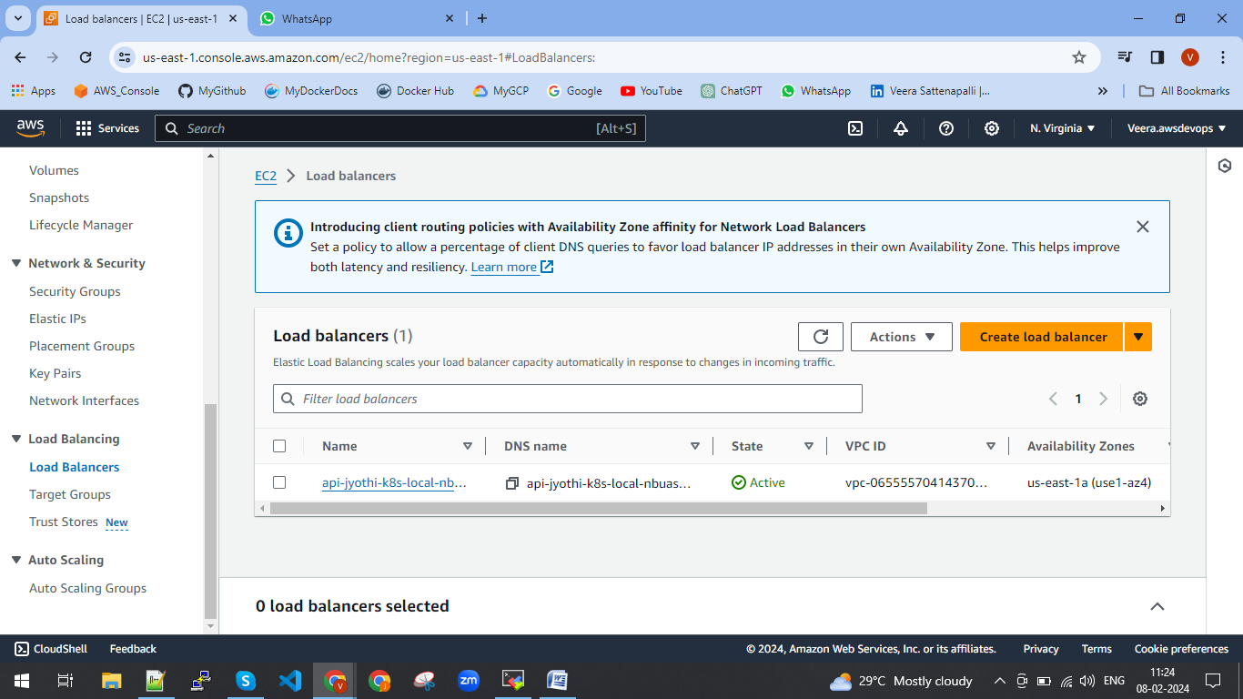

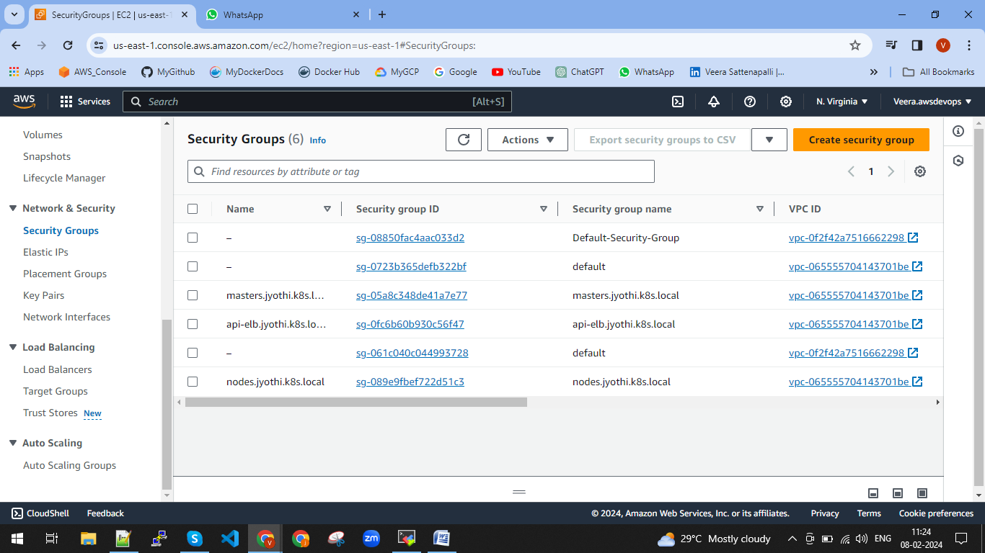

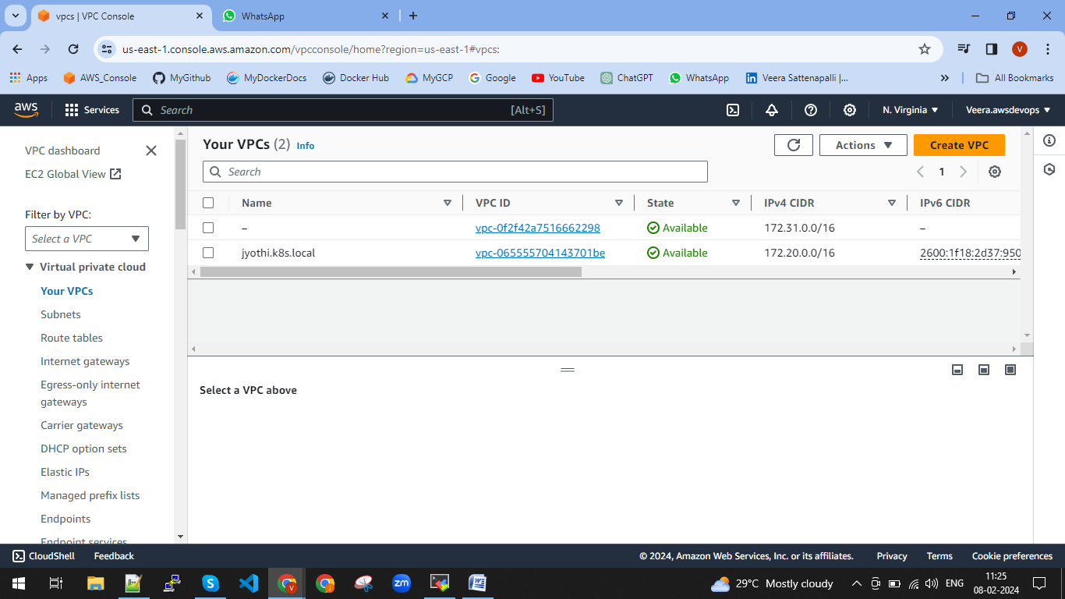

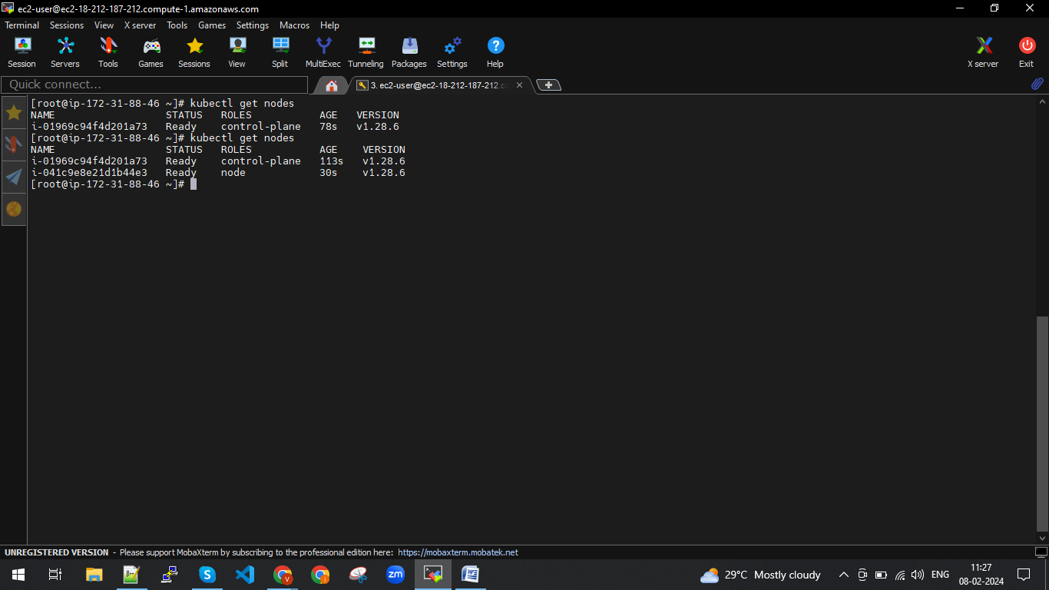

Those above which automatically created instances, auto scaling, load balancer, VPCs ect.,

We should not delete individually when ever we delete automatically again will genereate.

Hence we need to delete cluster.

**kops delete cluster --name jyothi.k8s.local --yes**